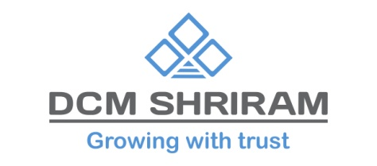
DCM Shriram Innovation Centre gets recognition from Department of Scientific and Industrial Research (DSIR), Ministry of Science & Technology, Government of India

19th March 2024: DCM Shriram Innovation Centre, an in-house R&D unit of DCM Shriram Ltd- Chemicals Business, has received the prestigious recognition of the “Department of Scientific and Industrial Research (DSIR)”, Ministry of Science & Technology, Government of India. The Innovation Centre, located in Vadodara, Gujarat was established in 2023 and is spread across 2.5 acres. It may be noted that the prestigious DSIR recognition is accorded to those in-house R&D units of organizations that are engaged in innovative research & development related activities such as development of new products, design & engineering, process /product /design improvements, etc.
In the short span since its inception, this centre has developed and demonstrated expertise in the areas of Organic Chemistry, Polymer Science, Materials Science, Water Technology and Process Scale-Up. It also has technical capabilities in Organic & Inorganic synthesis, Catalysis testing Facility, Material’s Characterization, Product formulations, Application Development Capabilities in polymers, FMCG, Oil & Gas, Paints, Chemicals cleaning & etching.
Going forward, the DCM Shriram Innovation Centre will focus on emerging areas such as epoxy in composites, Electricals, Construction & Coatings applications; differentiated product formulations in the space of water treatment chemicals, advanced materials based products -Functional & Structural applications and Product portfolios aligned to sustainability -Valorising chlorine through downstream derivatives.
With the objective of forging R&D collaborations, the centre has also tied up with several globally renowned academic and research institutions.

About DCM Shriram Ltd:
DCM Shriram Ltd. is a leading business conglomerate with a group turnover of Rs. 12,080 crores. The business portfolio of DCM Shriram primarily comprises of: Agri-Rual Business - Urea, Sugar, Farm Solutions and Hybrid Seeds ; Chlor-Vinyl Business - Caustic Soda, Chlorine, Calcium Carbide, Aluminium Chloride, PVC Resins, PVC Compounds, Power and Cement and Value Added Business - Fenesta Building Systems- UPVC & Aluminium Doors and Windows

*******

